Scott Snow

April 20, 2018

MBC 638

Project Definition Worksheet

**A. Problem statement.**

At Premier Building Systems, we manufacture Structurally Insulated Panels for residential and commercial construction. These panels take the place of traditional stick frame construction. They arrive at a construction site pre-fabricated requiring the builder to simply put the building together like a 3-D puzzle.

In my current manufacturing environment, defects are a source of frustration, disruption and monetary loss. Some defects are minor and can be fixed on the production line. Some are more severe and require an entire remanufacturing of the defective panel. As it currently stands, we spend a decent amount of time trying to find alternatives to a rework or trying to identify scrap material that we can substitute. I believe there is a more efficient way to improve our response time to a defective panel.

**B. Business impact.**

A defect that triggers a repress causes both frustration and decline in motivation among workers. It also slows production as there is often issues at the end of the line with waiting for the rework to get there. Furthermore, it costs the company more money as we need to use more materials than anticipated to complete the job. This can especially be an issue for jobs with special material requirements which then may cause us to delay completion or make sacrifices to appease the customer.

I feel that three things have the potential to increase our efficiency in this regard. The fist is a database containing the details of every scrap panel that we have in inventory. This will allow us to check if there is already laminated material available for when a defect arrives, and to check if we have a piece of scrap to use for a panel on a recently started job.

The second is a process that allows us to deliver a scrap panel to the front of the line in a manner that is efficient and safe. This could be either another line of rollers, a cart of some kind, or a path for a forklift to travel easily.

The third is a standard process that is followed based on these additions to increase the time it takes.

**C. Goals.**

Currently a rework can take some time to get back onto the line depending on the complexity of the layouts and the cuts. To know for certain of where we currently stand, I would need to take time measurements of our response time. However, from the time that a defect is identified as requiring a rework, we would get the rework available for layout at the start of the line in 20 minutes.

Additionally, a good measurement of the efficacy of the database is to have measurements of scrap utilization for the past few weeks, which I believe can be obtained. Then take the same measurement every few weeks to see if it improves.

I had the opportunity on Friday April 20th to observe the first element for my base sample of what our current average response time is. A panel was determined to have been laid out and cut incorrectly at 3:05, the insulation core was ready to be pressed at 3:24. The panel was pressed at 3:39. Its layout was finished at 4:17 with three other panels also laid out ahead of it. It was finally cut at 5:52. I believe the goals for improving this process for this situation could have allowed the rework to be completed by 3:35.

**D. Project scope.**

Since this is mostly a manufacturing process, it should be entirely within my scope. The only exception is if my manager wishes to continue to use the database aspect, it would then be moved to his work computer. This shouldn’t be an issue, the number of scrap panels that we currently have is around twenty. The scope is specifically for when the QA operator determines that a panel requires a rework and the determined course of action requires excess materials.

**E. Team.**

The process owner would be me, our QA operators, our production manager and the lead operators.

**F. Project plan (very high-level).** Estimate time (or date) per DMAIC step. Develop a rough timeline.

1. Define- This step will be completed once I finish the problem definitions worksheet. I am going to converse with the team outlined above to finalize all the details included.
2. Measure- This step may take some time as we are currently changing buildings and then I will be taking some time off at the start of next month. If our QA Operator is willing, I would like to create a form that allows him to document the time lapse between when he notifies the lead operator that a rework is needed and when he checks the new panel on the line. Potentially also have spots for each station that a rework goes through that he can attach to the production detail. Hopefully this step will be completed by May 19th.
3. Analyze- Since it doesn’t make sense to force defects, it would make sense to accomplish this at the same time. I believe the current root causes to be the following:
   1. A lack of transportation to efficiently move the reworked panel to the front.
   2. A lack of an efficient way to see if a potential scrap panel is available to be used thus saving the time and money required for a repress.
   3. A strict standard work that streamlines the repress process.
4. Implement- Once a solid enough base performance is established. We can implement the improvements I have outlined here. Also, if more ideas are suggested by the team, we can attempt to implement those as well. This process should be completed by the first week of June.
5. Control- This will be taking place after the first week of June and should take two weeks to adequately complete. It’s likely the project may still be in this phase when I turn in the final version.

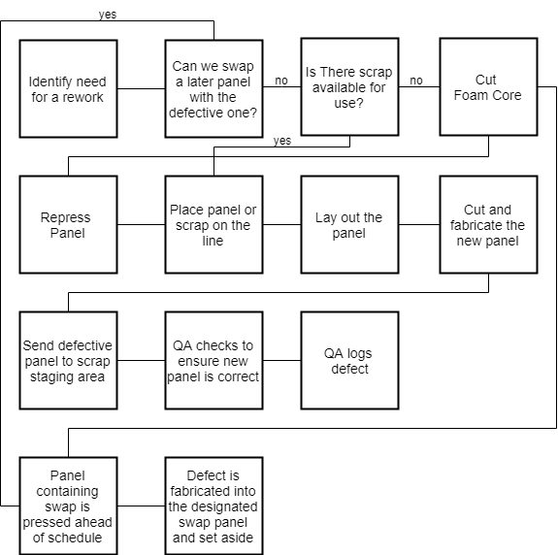**G. Process map**